<div data-cy=submit”></div>

cy.get('[data-cy=submit]').click()

use cy.request instead of cy.visit for 3rd party that you do not control

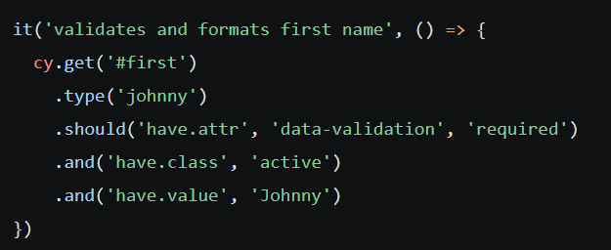

Clean up state **before** tests run

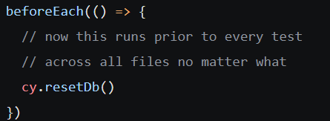

Clean up state in the before or beforeEach

